|  |  |
| --- | --- |
| Plan out the captions and transitions for your comic here before you begin to draw. | |
| My comic is about | |
| ADD TRANSITIONAL WORDS and phrases here. | Write the sequence of events in CAPTIONS here. |
|  |  |
|  |  |
|  |  |
|  |  |
|  |  |
|  |  |
|  |  |
|  |  |
|  |  |
|  |  |
|  |  |

**TRANSITION WORDS FOR TIME**

After a while

Immediately

Afterwards

During

Soon

At last

Finally

Later

Suddenly

First, (second, third, etc.)

Meanwhile

Then

Gradually

Now

Finally

In the beginning

At the end

Today

Tomorrow

Yesterday

That day

Over time

As soon as

Sometimes

As long as

Before

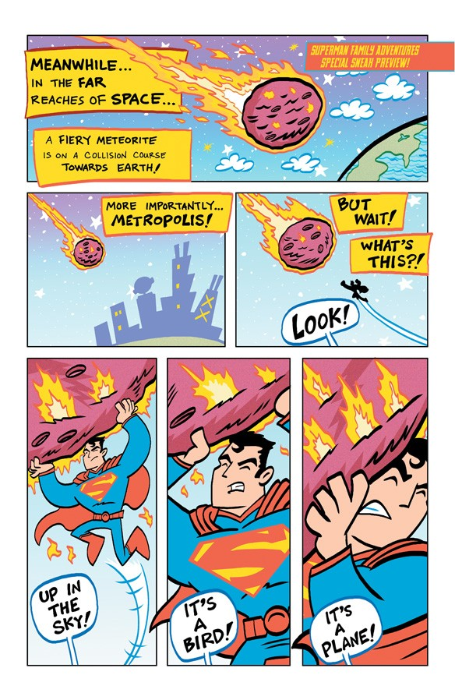Earlier

Simultaneously

So far

**TRANSITION WORDS FOR PLACE**

Above

Beside

In front of

Outside

Across

Beyond

Inside

To the east (west, etc.)

Among

Between

In the middle

Toward

Behind

Farther

Nearby

Within

Below

Here

Next

Somewhere on the other side of town